**REVISION HISTORY**

| **Date** | **Version** | **Description** | **Author** |
| --- | --- | --- | --- |
| 5.10.2024 | 1.0 | Created and added the Gantt chart. | D. Yağmur Uğut |
| 5.10.2024 | 1.1 | Listing individuals and their responsibilities. | Eda Nur Yılmaz |
| 6.10.2024 | 1.2 | Risk assessment part has been completed | Doruk Esen |
| 6.10.2024 | 1.3 | Document overview, and Requirements management and documentation completed, workstation partially completed | S. Poyraz Köroğlu |
| 6.10.2024 | 1.4 | Updated Workstation, Requirements management and documentation, Software Design, Coding and automated tests and Software development rules and standards parts | Ömer Emre Bozkurt |
| 6.10.2024 | 1.5 | Successfully completed the final revisions, ensuring all necessary adjustments were made for accuracy and clarity | Ö. Emre Bozkurt, Doruk Esen, Eda Nur Yılmaz, D. Yağmur Uğut, S. Poyraz Köroğlu |

**TABLE OF CONTENTS**

**Revision History 1**

**1** **Identification 3**

***1.1*** ***Document overview 3***

***1.2*** ***Abbreviations 3***

1.2.1 Abbreviations 3

***1.3*** ***References 3***

1.3.1 Project References 3

**2** **Software Development Activities 3**

***2.1*** ***Software development process 3***

2.1.1 Overview of process phases 3

2.1.2 Technical documentation 4

2.1.3 Deliverables 4

***2.2*** ***Software development tools 4***

2.2.1 Workstation 4

2.2.2 Requirements management and documentation 4

2.2.3 Software Design 4

2.2.4 Coding and automated tests 4

2.2.5 Configuration management 4

***2.3*** ***Software development rules and standards 4***

**3** **Responsibilities 5**

***3.1*** ***Activities and responsibilities 5***

**4** **Risk Assessment 5**

***4.1*** ***Risk Analysis 5***

***4.2*** ***Risk Planning 5***

# **Identification**

## ***Document overview***

This document contains the software development plan of software “Space Blasters”.

Our project “Space Blasters” will be a classic arcade game for computers. The game app will be accessible directly from the desktop and won’t need an internet connection to play. The game will take the best of the classical arcade games “Space Invaders” and “Pong”. Instead of directly shooting hostiles from a spaceship, We will use a ball and a rectangular shape which the ball is going to bounce off of to eliminate the hostiles. We hope that this is going to add mechanical depth to our game which the games we took elements from were missing.

## ***Abbreviations***

### **Abbreviations**

SB: Space Blasters

UML: Unified Modeling Language

IDE: Integrated Development Environment

JDK: Java Development Kit

SRS: Software Requirement Specification

STP: Software Test Plan

SDD: Software Design Document

STR: Software Test Report

VFX: Visual effects

SFX: Sound effects

## ***References***

### **Project References**

| # | Document Identifier | Document Title |
| --- | --- | --- |
|  |  |  |

# **Software Development Activities**

The section lists and describes the software development activities of the “Space Blasters” software development project.

## ***Software development process***

This is a course project, which adopts the waterfall model as the software development process.

### **Overview of process phases**

The software development process for the project will be composed of the following phases:

* Planning
* Requirements Analysis
* Design
* Implementation
* Testing and Analysis

These phases will follow each other sequentially, where each phase starts just after the completion of the previous one. The following Gantt chart depicts the planned start date and duration for the phases.

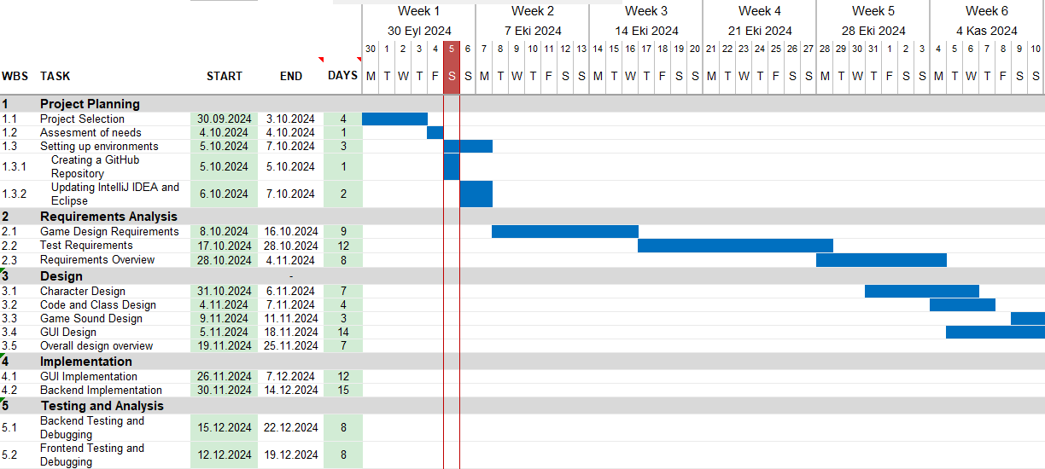

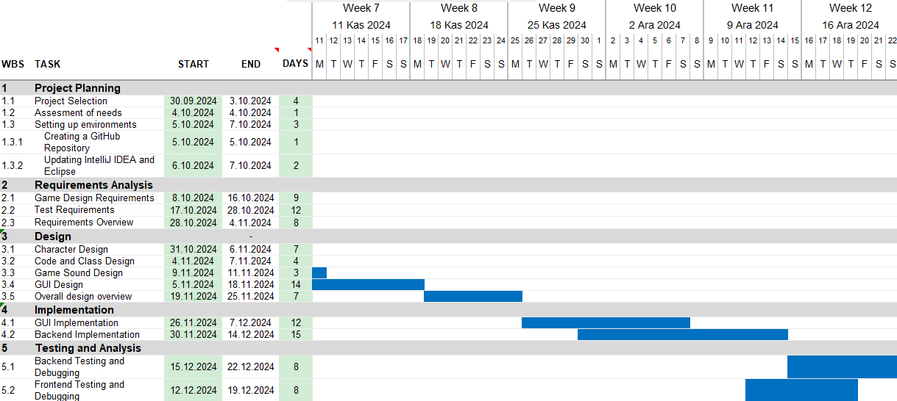

### **Technical documentation**

The following documentation is produced during the software development phases:

* Software specification: SRS, STP
* Software detailed conception: SDD
* Software tests phases : STR
* Software analysis: SAR

### **Deliverables**

The following items will be delivered at the end of the process:

* Technical documentation as outlined in Section 2.1.2
* Software and its configuration files

## ***Software development tools***

### **Workstation**

To create the game we have imagined, we have to have the necessary equipment to be able to work as a team simultaneously. That is why we have decided to work with our most capable devices.

**Our Devices:**

* Monster Tulpar T5 V19.2 RAM:32GB, GPU: Nvidia RTX2060, CPU: Intel Core i7-10750H, SSD:256GB, HDD: -

* Huawei Matebook D16, RAM:16GB, GPU: Intel Iris X Graphics, CPU: Intel Core i7-12700H, SSD:512GB, HDD: -

* MacBook Air M1: RAM:8GB, CPU: Apple M1, SSD: 256GB, HDD-, Speaker: Stereo

* HP Victus 16-R1050NT, RAM:32GB, GPU: Nvidia RTX 4050, CPU: Intel Core i7-14700HX, SSD: 1TB, HDD: -

* MSI Prestige 14 Evo B13M, RAM: 32 GB, GPU: Intel Evo Graphics, CPU: Intel Core i7-13700H 2.40 GHz, SSD: 1TB, HDD: -

### **Requirements management and documentation**

Microsoft Word, Google Docs, Zoom, Intellij Idea, Eclipse, Github.

### **Software Design**

Describe tools used for software design :

* Argo UML open source tool, LibGDX, etc.

### **Coding and automated tests**

Describe tools used for coding and automated tests.

* Eclipse + list of plugins or IntelliJ IDEA + list of plugins
* Junit

### **Configuration management**

GitHub[1] will be used for software configuration management and tracking issues regarding the software development. A public repository will be created for this purpose.

## ***Software development rules and standards***

UML[2] will be used for software design documentation.

Java Coding Conventions: <http://www.oracle.com/technetwork/java/codeconvtoc-136057.html>

# **Responsibilities**

## ***Activities and responsibilities***

| **Activity** | **Responsibility** | **Comment** |
| --- | --- | --- |
| Project management | Eda Nur Yılmaz | Preparing the meetings, coordinating and assigning tasks. |
| Configuration tools management | Doğa Yağmur Uğut, Ömer Emre Bozkurt | Setting up the configuration management tools to identify potential errors and handle deployments. |
| UML Diagram | Eda Nur Yılmaz | Creating the UML Diagram for the software.. |
| Setting up the Development tools | Doğa Yağmur Uğut, Doruk Esen | Installing the necessary development tools/programs and setting them up. |
| Software Testing and Debugging | Eda Nur Yılmaz, Ömer Emre Bozkurt | Testing the software with different dummy variables, checking and modifying the software accordingly. |
| GUI Design and implementation | Poyraz Köroğlu, Doruk Esen | Implementing the GUI and frontend. |
| Visual Design | Ömer Emre Bozkurt | Designing engaging visuals and ensuring design consistency. |
| Sound Design | Doruk Esen, Poyraz Köroğlu | Creating audio effects and compositions. |

# **Risk Assessment**

## ***Risk Analysis***

| Risk Type | Possible Risks |
| --- | --- |
| Tool | Desired tools for the project outsource the project's budget and stop the project’s development phase. (1) |
| People | People working on the project are not qualified to accomplish their assigned parts. (2)  People working on the project have personal arguments which cause a lack of contribution. (3) |
| Organizational | Lack of communication occurs at any point resulting in an overall quality deficit for the project (4) |
| Technology | VFX and SFX do not work at the same time and yield incorrect results. (5) |
| Requirements | Any requests for the project after its design phase result in major rework. (6) |
| Estimation | The qualifications of the team members are overestimated. (7)  The time required to complete the project is underestimated. (8) |

| Risk | Probability | Effect |
| --- | --- | --- |
| Desired tools for the project outsource the project's budget and stop the project’s development phase. (1) | Very low | Moderate |
| People working on the project are not qualified to accomplish their assigned parts. (2) | Moderate | Tolerable |
| People working on the project have personal arguments which cause a lack of contribution. (3) | Low | Tolerable |
| Lack of communication occurs at any point resulting in an overall quality deficit for the project (4) | Moderate | Serious |
| VFX and SFX do not work at the same time and yield incorrect results. (5) | High | Tolerable |
| Any requests for the project after its design phase results in major rework. (6) | Low | Serious |
| Qualifications of the team members are overestimated. (7) | High | Moderate |
| Time required to complete the project is underestimated. (8) | Moderate | Serious |

## ***Risk Planning***

| Risk | Strategies |
| --- | --- |
| Lack of budget | If there is a lack of budget to use some software/hardware, free or low-cost alternatives of those systems shall be used. |
| Lack of qualification | If any individual or group fails to accomplish their designated part, new individuals or groups may be reassigned to those parts to cover up and assist. |
| Personal Problems | If 2 or more individuals do not get along well their parts will be monitored by another team member and communication between them will be dealt with with the help of 3rd individuals. |
| Lack of communication | The project manager can call for emergency meetings whenever it seems necessary to minimize the lack of communication. Also if any team member believes there is a problem regarding communication they are free to ask the manager to call for emergency meetings. |
| Overlapping effects | If VFX and SFX overlap each other or do not work properly as planned, the effect that causes the problem shall be changed by an alternative one. |
| Change of design | Any request to change the design after the implementation of the design will be refused and the customer will be asked to give feedback regarding other topics. |
| Overestimated Qualifications | If any group member realizes that any other member or themselves are not qualified for their assigned job will immediately notify the project manager and schedule a low-budget or free training course regarding their weaknesses. |
| Underestimated Time | If any part of the project is foreseen to be delayed other individuals will be asked to assist that part as soon as possible to not damage the overall structure of the project. |

| Risk Type | Potential Indicators |
| --- | --- |
| Tool | Not being able to use all aspects of the software or the hardware |
| Knowledge | Badly implemented code |
| Communicational | Not enough meetings and not knowing what others do |
| Time estimation | Request for an extension for more than 12 hours |
| People | High tension in the meetings, not being respectful towards each other |
| VFX and SFX | Hearing cracked sounds or not getting visual updates |

1. <http://www.github.com>
2. <http://www.uml.org/>